Classification of elliptic functions using a mechanical model.

Guennadi Levkine (email hlevkin@gmail.com)

Mathship Technologies
Gibsons, BC, Canada

Abstract. P

Key words:

$\frac{∂^{2}P}{∂x^{2}}$ $\frac{\text{dX}(t)}{\text{dt}}=−m∗X(t)$

1. Introduction: problem and terminology

Importance of elliptic functions. They are the next after cosine, sine, and exponential functions.

$F(x)\text{= -}\frac{\text{dU}(x)}{\text{dx}}$

2. Trigonometric functions Cos, Sin and their treatment

$U(x)=(k/2)∗x\hat{2}$

Differential equations

$m∗\frac{d^{2}X(t)}{{\text{dt}}^{2}}$

3. Expo function Exp and their treatment

$U(x)=−(k/2)∗x\hat{2}$

Differential equations

$m∗\frac{d^{2}X(t)}{{\text{dt}}^{2}}$

4. Elliptic functions sn, cn, dn

$U(x)=(k/4)∗x\hat{4}$

Differential equations

$m∗\frac{d^{2}X(t)}{{\text{dt}}^{2}}$

5. Expo Elliptic functions

$U(x)=−(k/4)∗x\hat{4}$

Differential equations

$m∗\frac{d^{2}X(t)}{{\text{dt}}^{2}}$

6. C.

Make it

7. C

Make it

8. C.

Make it yourself.

10. Conclusions.

Make it

11. Acknowledgments.

We are very thankful to researchers who …

Literature

1.

2.

3.

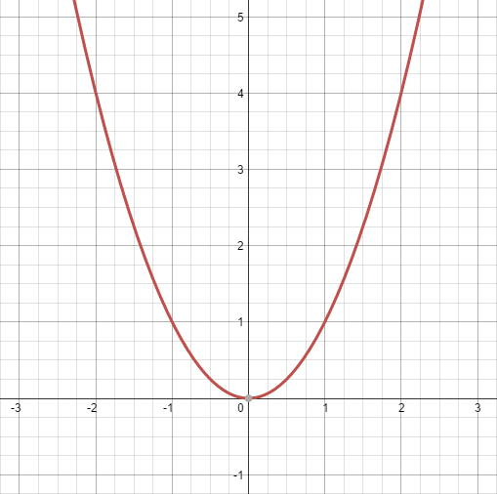

Picture 1. Parabola y = x^2

. 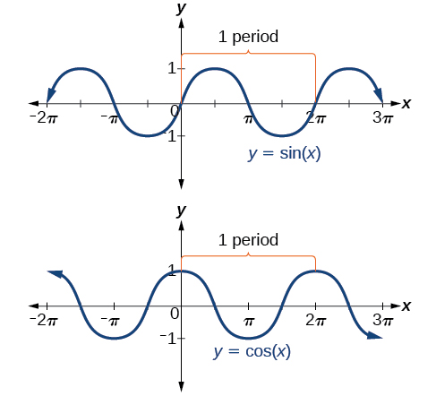

Picture 2. Sin / Cos graphs

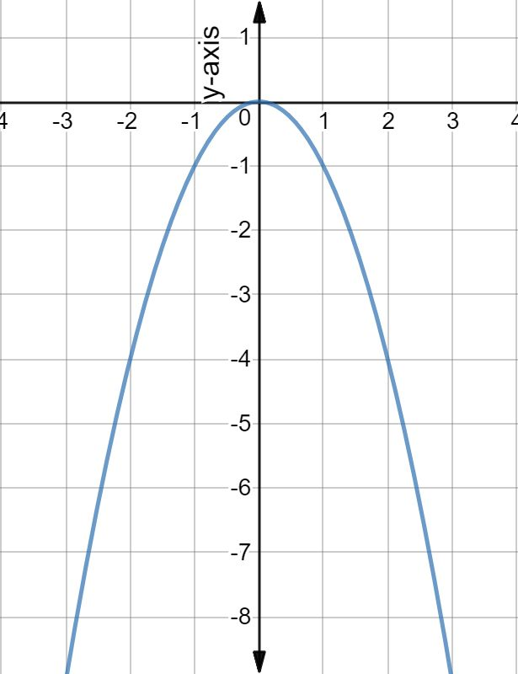

Picture 3. Parabola y = - x^2

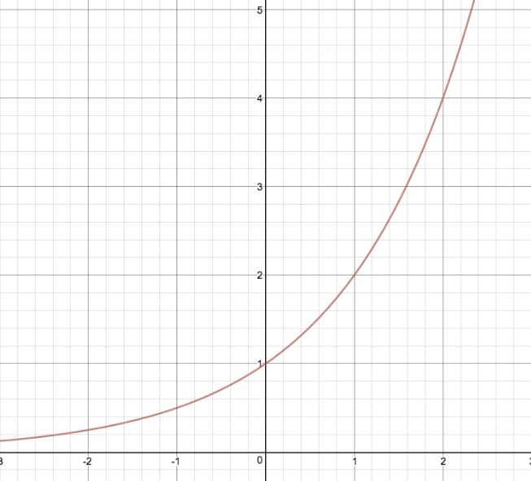

Picture 4. Exponential Function y(t) = exp(t) graph

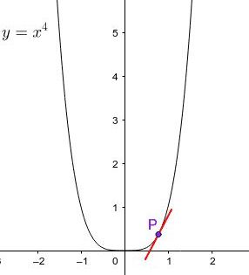

Picture 5. Tetric Parabola y = x^4

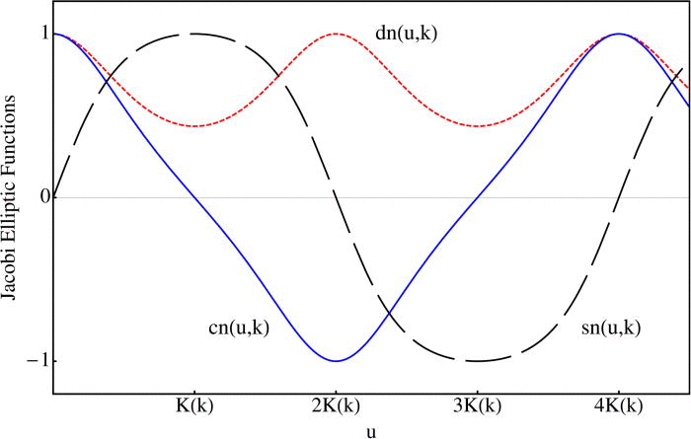

Picture 6. Elliptic functions sn, cn, dn graphs

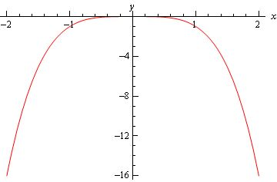

Picture 7. Tetric Parabola y = - x^4

Picture 8. Expo elliptic functions ex graphs

